

**KERİM MORAL**

**518191043**

**EKF-PF Based Localisation Comparison**

**for Different System Parameters**

**KOM 613E - Probabilistics Methods in Robotics**

**Prof. Dr. Hakan TEMELTAŞ**

Contents

1. Introduction 2

2. EKF-PF Comparison with Gaussian Distribution 2

3. EKF-PF Comparison with Triangular Distribution 3

4. EKF-PF Comparison with External Disturbance 4

5. EKF-PF Comparison with Less Particles 5

6. EKF-PF Comparison with More Objects and Increased Sensor Range 6

## Introduction

Extended Kalman Filter (EKF) implementation was already implemented in previous Home works. With this work, Particle Filter (PF) will also be designed and similarities and differences will tried to be highlighted.

A GUI has been designed as can be seen on Figure 1. In this GUI, different sensor parameters can be adjusted and different disturbance models such as Gaussian or Triangle can be selected while an external disturbance can also be applied.

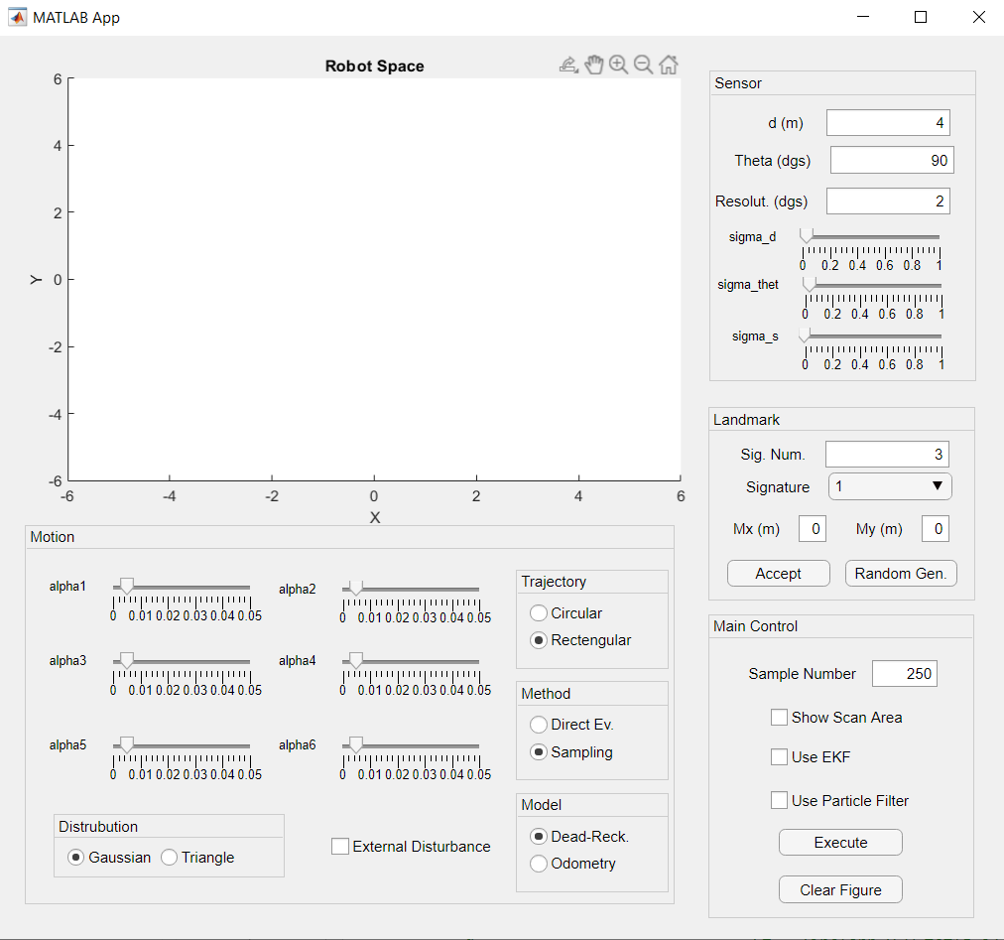

Figure 1 Designed GUI

## EKF-PF Comparison with Gaussian Distribution

Both EKF and PF have been tried with the same parameters as can be seen on Figure 2. Sample number has been taken as 250. Here, black dots are platform positions without any filtering, brown dots belong to EKF and green dots are PF. By general comparison, it can be seen that they operate similar while EKF is a little bit more accurate at the beginning. A closer look to the Ellipsoids can be seen on the right side of Figure 2. Range of the platform and the detected objects can be seen on Figure 4 for PF results. Figure 3 shows error Ellipses for those distributions. Blue ellipses are for EKF and red ones are PF.

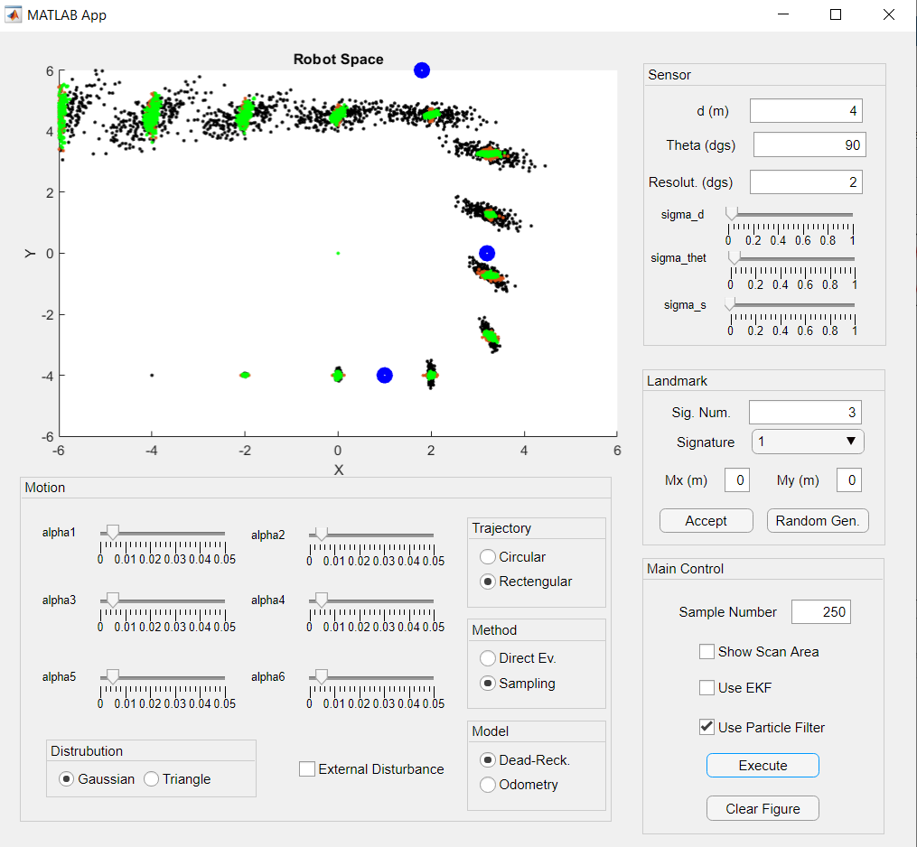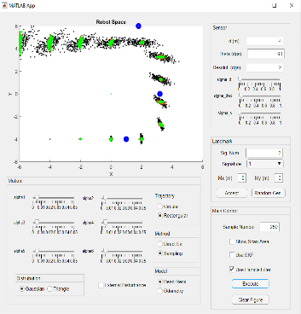

Figure 2 EKF-PF Comparison with Gaussian Distribution

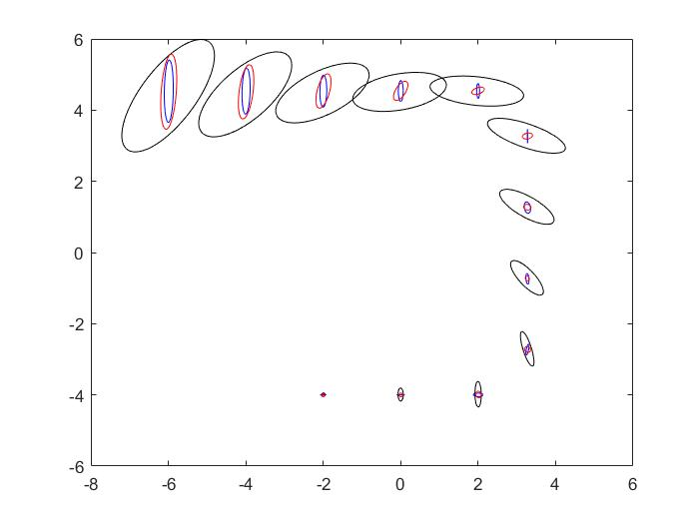

Figure Erorr Ellipses

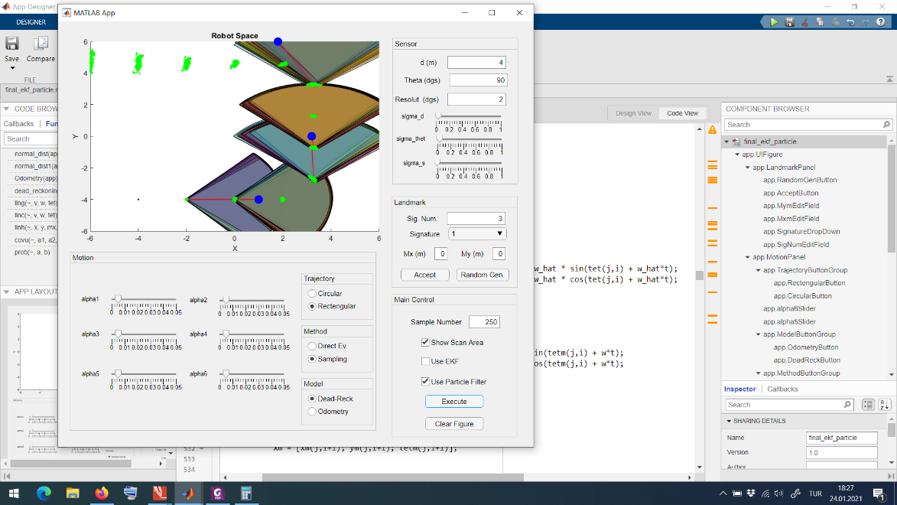

Figure 4 Detected Objects and Scan Range

## EKF-PF Comparison with Triangular Distribution

Same test procedure with Section 1 has been applied with changing distribution type to Triangular distribution. Purpose of this test was to compare EKF and PF for non-gaussian distribution types since EKF makes a Gaussian approximation. Results were similar to the Gaussian type but both filters are now much closer. Results can be seen on Figure 5.

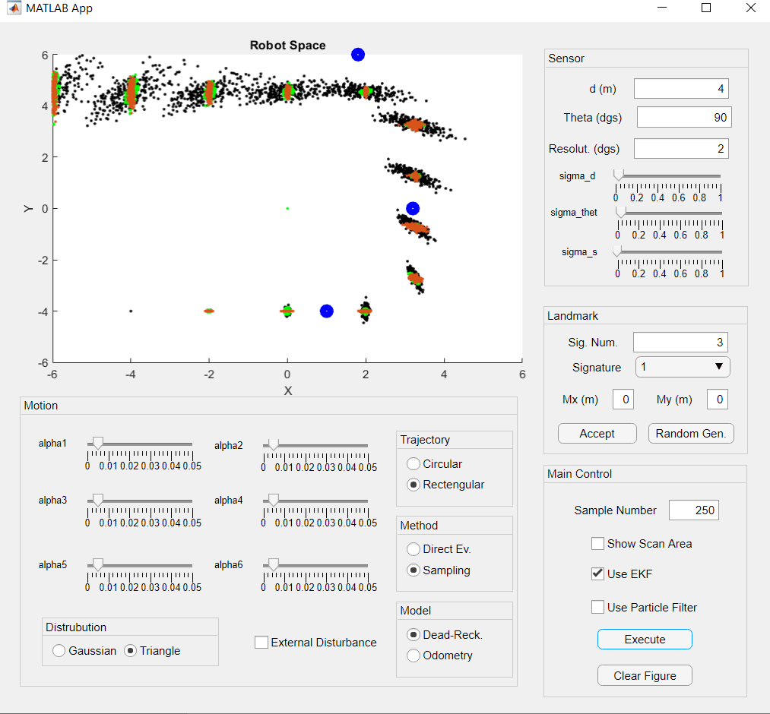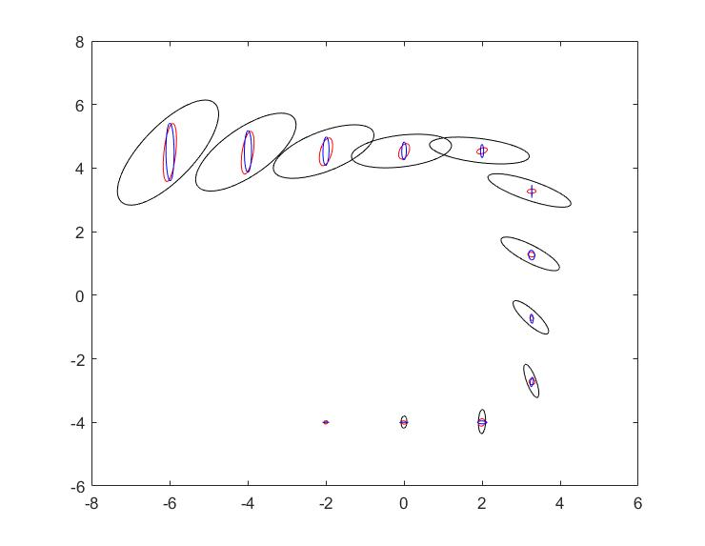

Figure 5 EKF-PF Comparison for Triangular Distribution

## EKF-PF Comparison with External Disturbance

An external disturbance for velocity has been applied at k=7 with vd = 1 m/s to see how both filters will react to an unexpected non-gaussian distribution. Results can be seen on Figure 6. EKF estimations are scattering much faster after distribution while PF estimations are still pretty accurate.

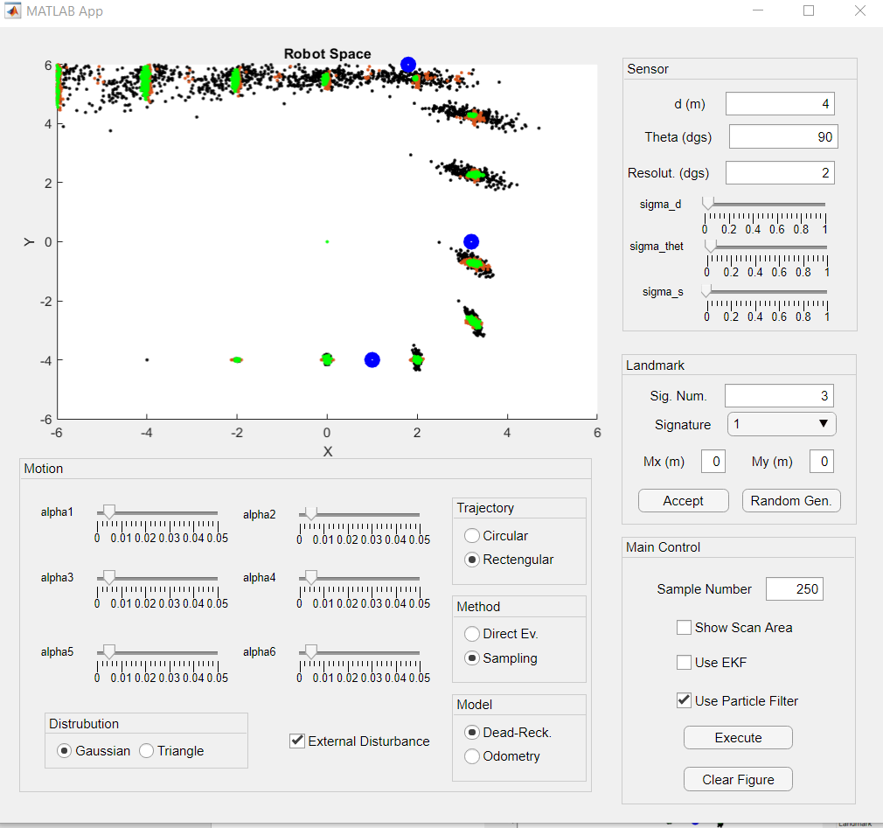

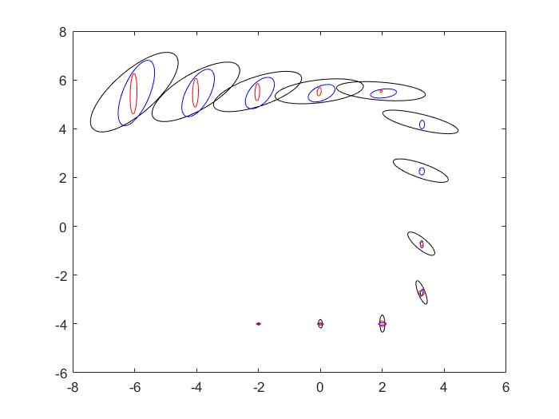

Figure 6 External Disturbance Results

## EKF-PF Comparison with Less Particles

Above experiments have been done with sample number of 250. Sample number has been decreased in order to see if PF performance will get lower or not. Results can be seen in Figure 7. While both filters result similar PF is again slightly better.

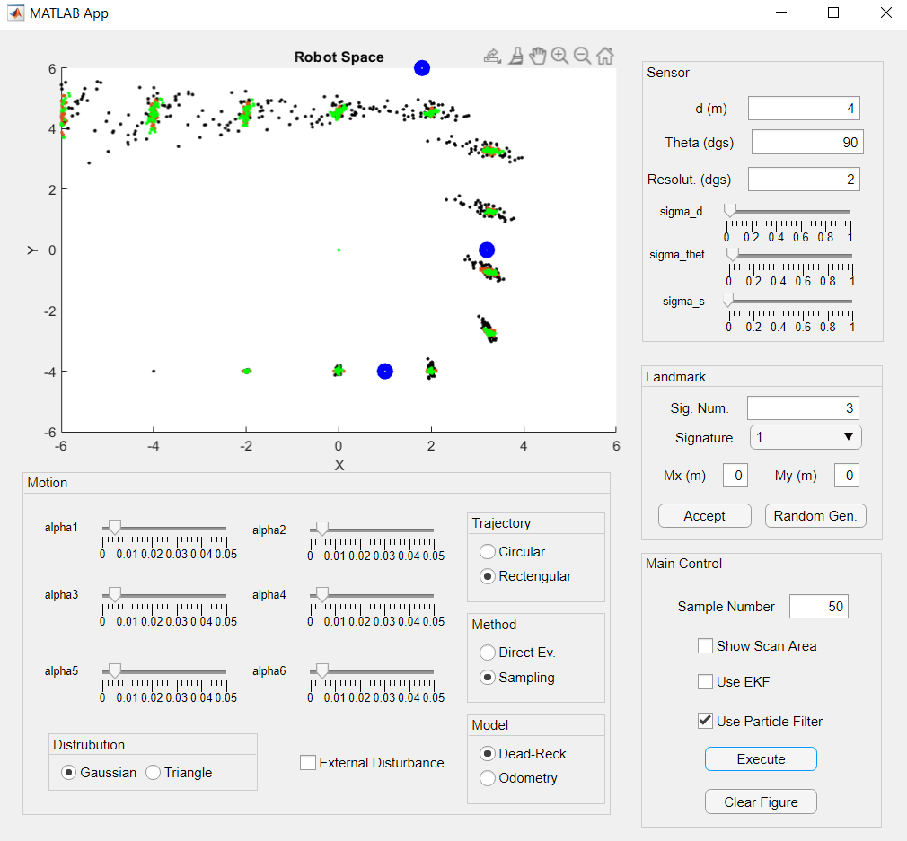

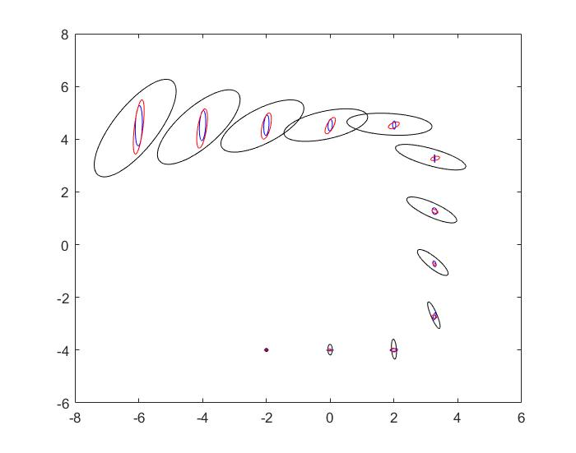

Figure 7 EKF-PF Comparison for N=50

## EKF-PF Comparison with More Objects and Increased Sensor Range

In the final experiment, object number has been increased from three to ten while sensor range has been adjusted as ten meters in order to compare filters when there are more measurement. Results of this test can be seen on Figure 8. While at the beginning EKF performs better than PF, as the time goes on EKF estimations distributed more and they operate similar around k=10.

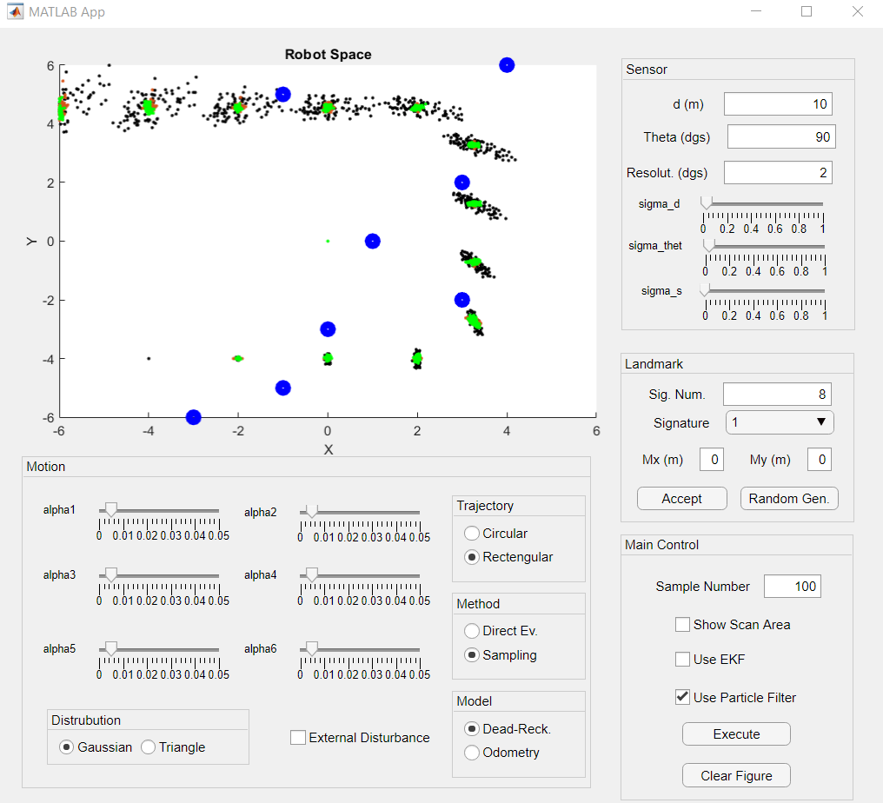

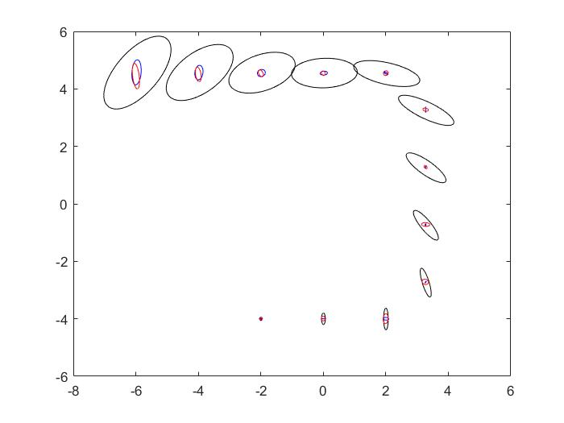

Figure 8 EKF-PF Comparsion with Increased Measurements